1. This document explains how to use the budgeting spreadsheet.
2. Button names are shown in blue, and the names of cells are shown in **bold.**

Allowances



1. The **Allowances** row indicates how much money is allotted for each category. Values of zero are shown in yellow. Negative values are shown in red.
2. The values can be updated by clicking Add Entry, Delete Last Row, or Transfer.
3. Above the **Allowances** row is a row of percentages. This indicates the percentage of the total budget that each category is assigned. These percentages can be changed manually. Note: if the percentages do not add up to 100%, you will have to correct them.

Totals



1. The **Totals** row indicates how much money is in a bank account, or in cash, or in gift cards. The sum is also shown. Values of zero are shown in yellow. Negative values are shown in red.
2. The values can be updated by clicking Add Entry or Delete Last Row**.**

Records



1. The **Records** section shows entries made by clicking Add Entry.
2. It shows the year, month, week, day, and date of each entry, as well as the category, an item description, the amount of items, whether it was a debit or credit, and the type of payment. It also shows the total debits and credits.
3. It can be sorted by clicking Sort Expenses by date.
4. The last entry can be removed by clicking Delete Last Row**.**

This Week and This Month

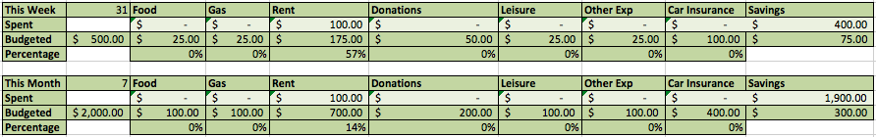

1. **This Week** and **This Month** show the sum of expenses in each category incurred in the current week and month. These pull data from the **Records** section.
2. Also displayed is the budgeted amount for each category, per week and per month. These are calculated from the percentages entered in the row above the **Allowances** row.
3. Also displayed is the percentage of funds in each category that have been spent in the current week or month.

Add entry button and Entry Row





1. The Add entry button enters a new record into the **Records** section based on information entered into the **Entry Row**.
2. The fields **Date**, **Category**, and **Payment Type** are required. Either **Debit** or **Credit** must contain an amount.
3. The **Category** and **Payment Type** fields each contain a drop down list of permitted values.
4. Add entry will update the **Allowances** row, **This Week** section, **This Month** section, the **Records** section, and the **Totals** row.
5. If the **Category** field is set to Income or Tax, funds will be distributed into the **Allowances** row according to the percentages entered directly above the **Allowances** row.

Sort expenses by date button

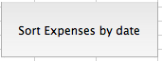

1. This button sorts the **Records** section by date.
2. It displays a confirmation message upon finishing the sort.

Clear entry row button

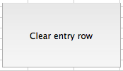



1. This returns the **Entry Row** to its default empty values.
2. It ensures the **Date** is today’s date.
3. It does not change the **Category** field or **Payment Type** field.

Transfer button





1. This updates the **Allowances** row.
2. It moves a specified amount of money from one Category to another, using the input fields **From**, **To**, and **Amount**.
3. The **From** and **To** fields each has a drop down list which guides the user to the allowed options.

Delete last row button

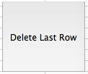

1. This removes the bottom row of the **Records** section.
2. It updates the **Allowances** row, **This Week** section, **This Month** section, the **Records** section, and the **Totals** row.
3. It shows a confirmation message before making the changes.